Overview of Git/GitHub

In this video, you’ll get an overview of Git and GitHub, which are popular environments among developers and data scientists for performing version control of source code files and projects and collaborating with others. You can’t talk about Git and GitHub without a basic understanding of what version control is.

A version control system allows you to keep track of changes to your documents. This makes it easy for you to recover older versions of your document if you make a mistake, and it makes collaboration with others much easier. Here is an example to illustrate how version control works. Let’s say you’ve got a shopping list and you want your roommates to confirm the things you need and add additional items. Without version control, you’ve got a big mess to clean up before you can go shopping. With version control, you know exactly what you need after everyone has contributed their ideas.

Git is free and open source software distributed under the GNU General Public License. Git is a distributed version control system, which means that users anywhere in the world can have a copy of your project on their own computer. When they’ve made changes, they can sync their version to a remote server to share it with you. Git isn’t the only version control system out there, but the distributed aspect is one of the main reasons it’s become one of the most common version control systems available. Version control systems are widely used for things involving code, but you can also version control images, documents, and any number of file types. You can use Git without a web interface by using your command line interface, but GitHub is one of the most popular web-hosted services for Git repositories. Others include GitLab, BitBucket, and Beanstalk. There are a few basic terms that you will need to know before you can get started. The SSH protocol is a method for secure remote login from one computer to another. A repository contains your project folders that are set up for version control. A fork is a copy of a repository. A pull request is the way you request that someone reviews and approves your changes before they become final. A working directory contains the files and subdirectories on your computer that are associated with a Git repository. There are a few basic Git commands that you will always use. When starting out with a new repository, you only need create it once: either locally, and then push to GitHub, or by cloning an existing repository by using the command "git init".

"git add" moves changes from the working directory to the staging area. "git status" allows you to see the state of your working directory and the staged snapshot of your changes. "git commit" takes your staged snapshot of changes and commits them to the project. "git reset" undoes changes that you’ve made to the files in your working directory. "git log" enables you to browse previous changes to a project. "git branch" lets you create an isolated environment within your repository to make changes. "git checkout" lets you see and change existing branches. "git merge" lets you put everything back together again. To learn how to use Git effectively and begin collaborating with data scientists around the world, you will need to learn the essential commands. Luckily for us, GitHub has amazing resources available to help you get started. Go to try.github.io to download the cheat sheets and run through the tutorials. In the following modules, we'll give you a crash course on setting up your local environment and getting started on a project.
n this video, you’ll get an overview of Git and GitHub, which are popular environments among developers and data scientists for performing version control of source code files and projects and collaborating with others. You can’t talk about Git and GitHub without a basic understanding of what version control is. Reproduce el video desde ::30 y sigue la transcripción0:30 A version control system allows you to keep track of changes to your documents. This makes it easy for you to recover older versions of your document if you make a mistake, and it makes collaboration with others much easier. Here is an example to illustrate how version control works. Let’s say you’ve got a shopping list and you wan: agregado a la selección Presiona [CTRL + S] para guardar como nota.

Introduction to GitHub

Welcome to Introduction to GitHub After watching this video, you will be able to: Describe the purpose of source repositories and explain how GitHub satisfies the needs of a source repository. Linux development in the early 2000’s was managed under a free-to-use system known as BitKeeper. In 2005, BitKeeper changed to a for-fee system which was problematic for Linux developers for many reasons. Linus Torvalds led a team to develop a replacement source-version control system. The project ran in a short a timeframe and the key characteristics were defined by a small group. These include: Strong support for non-linear development. (Linux patches were then arriving at a rate of 6.7 patches per second) Distributed development. Each developer can have a local copy of the full development history. Compatibility with existing systems and protocols. This was necessary to acknowledge the diversity of the Linux community. Efficient handling of large projects. Cryptographic authentication of history. This makes certain that distributed systems all have identical code updates. Pluggable merge strategies. Many pathways of development can lead to complex integration decisions that might require explicit integration strategies. What is special about the Git Repository model? Git is designed as a distributed version-control system. Primarily focused on tracking source code during development. Contains elements to coordinate among programmers, track changes, and support non-linear workflows. Created in 2005 by Linus Torvalds for distribution of Linux kernels. Git is a distributed version-control system that is used to track changes to content. It serves as a central point for collaboration with a particular focus on agile development methodologies. In a central version control system, every developer needs to check out code from the central system and commit back into it. As Git is a distributed version control, each developer has a local copy of the full development history, and changes are copied from one such repository to another. Each developer can act as a hub. When Git is used correctly, there is a main branch that corresponds to the deployable code. Teams can continuously integrate changes that are ready to be released and can simultaneously work on separate branches in between releases. Git also allows centralized administration of tasks with access-level controls for each team. Git can co-exist locally such as through the GitHub Desktop client or it can be used directly through a browser connected to the GitHub web interface. IBM Cloud is based on sound and established open-source tools including Git repositories, often called repos. GitHub is an online hosting service for Git repositories. GitHub hosted by a subsidiary of Microsoft. GitHub offers free, professional and enterprise accounts. As of August 2019, GitHub had over 100M repositories. A Repository is: A data structure for storing documents including application source code. A repository can track and maintain version-control. GitLab is a complete DevOps platform, delivered as a single application. GitLab provides access to Git repositories, controlled by source code management. With GitLab, developers can: Collaborate, reviewing code, making comments and helping to improve each other’s code. Work from their own local copy of the code. Branch and merge code when required. Streamline testing and delivery with Built-in Continuous Integration (CI) and Continuous Delivery (CD). In this video, you learned: GitHub is the online hosting service for Git repositories. Repositories store documents including application source code and enable contributors to track and maintain version-control. What is special about the Git Repository model? Git is designed as a distributed version-control system. Primarily focused on tracking source code during development. Contains elements to coordinate among programmers, track changes, and support non-linear workflows.

ab: Getting started with GitHub

Estimated time: 20 minutes
In this lab, you will get started with GitHub by creating a GitHub account and project. You will then add a file to the project using the GitHub web interface.

Objectives
After completing this lab, you will be able to:
- Describe GitHub
- Create a GitHub account
- Add a project / repository
- Create and edit a file
- Upload and commit a file

GitHub overview
Before we learn to use GitHub, let's first review Git. Git is an open source version-control system for software development. It is simply a place where you can collect all your folders and files for a project. This collection of folders and files is usually called a repository.
GitHub is a Git repository hosting service, but it adds many of its own features. While Git is a command-line tool and you also need to host and maintain a server using the command line, GitHub provides the Git server for you, as well as a web-based graphical interface. It also provides access control and several collaboration features, such as wikis and basic task management tools, for every project.
GitHub provides cloud storage for source code, supports all popular programming languages, and streamlines the iteration process. GitHub includes a free plan for individual developers and for hosting open source projects.

1. Creating a GitHub account
To create an account in GitHub, complete the following steps:
- Go to the Join GitHub page and create an account. Note: If you already have a GitHub account, log in now.
- Provide the necessary details to create an account as shown below. When you have finished, click Create account.
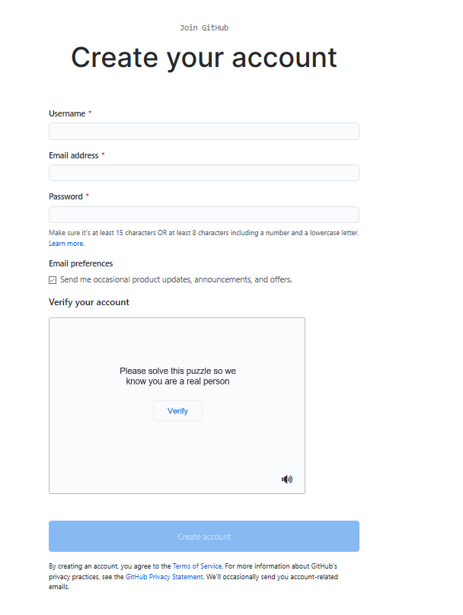
- Click Verify to verify the account and then click Done.
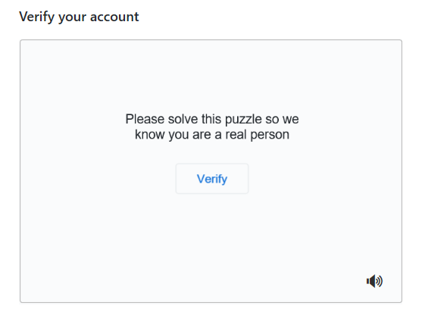
- After you have verified, click Join a Free Plan.
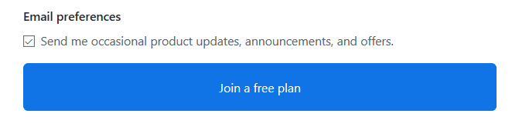
- Select your reasons for joining GitHub and click Complete Setup.
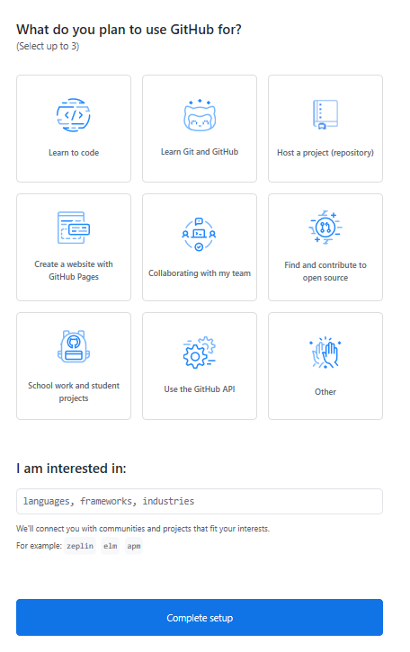
- You will receive a verification email from GitHub. Click the enclosed link to verify your email. Note: If you do not receive a verification email, click Resend verification email.
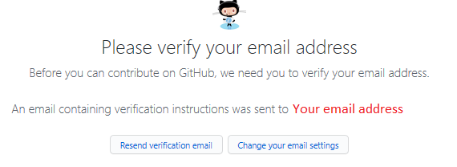
When you have verified your email, you will see a screen that looks like this:
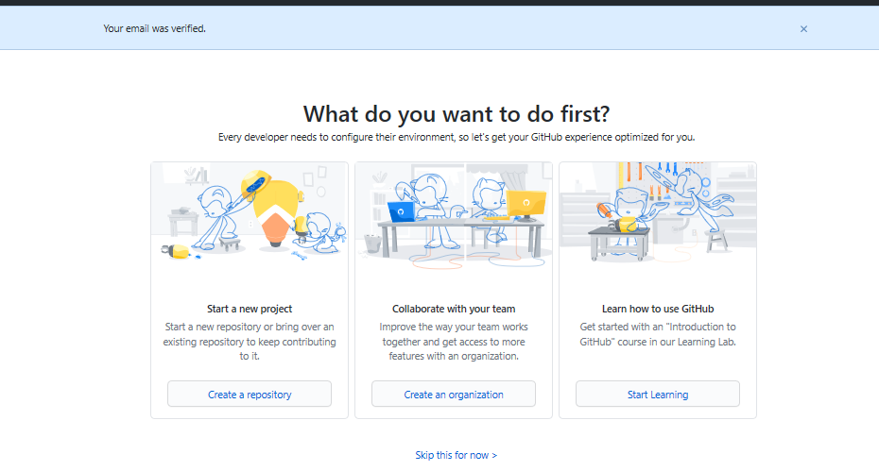

2: Add a project / repository
To add a new repository, complete the following steps:
- At the top right of the GitHub home page, click on the "+" icon and select New repository.
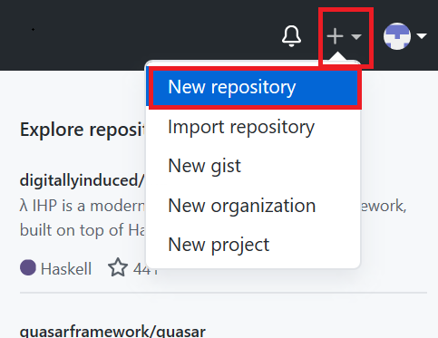
- Enter a repository name and select the Initialize this repository with a README check box.
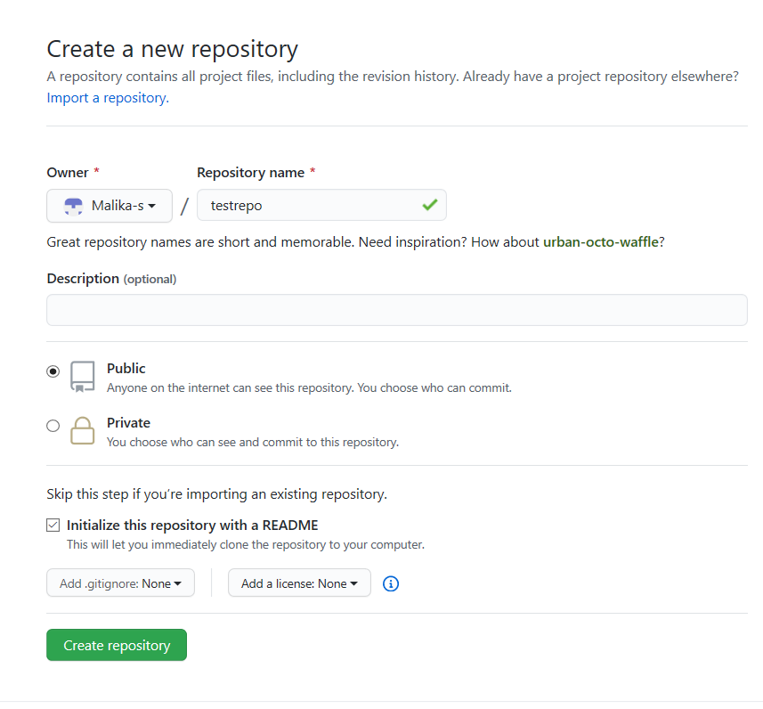
- Click Create repository. The repository is created and its home page is displayed.
Next, you'll start editing the repository.

3: Create and edit a file
Edit a file
Although you will normally create a file before you edit it, in this case the README.md file has already been created for you. To edit that file, complete the following steps:
- Your repository root folder contains just one file: README.md. Click the pencil icon at the right to edit the file.
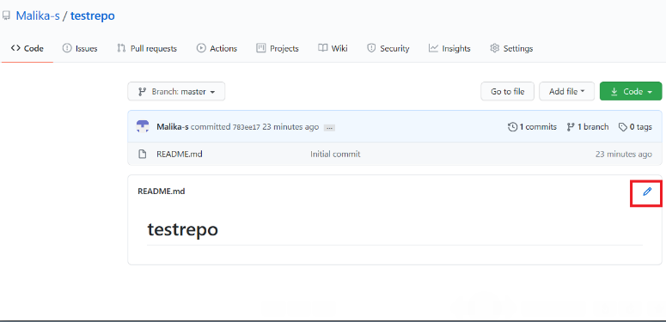
- Add some text to the file.
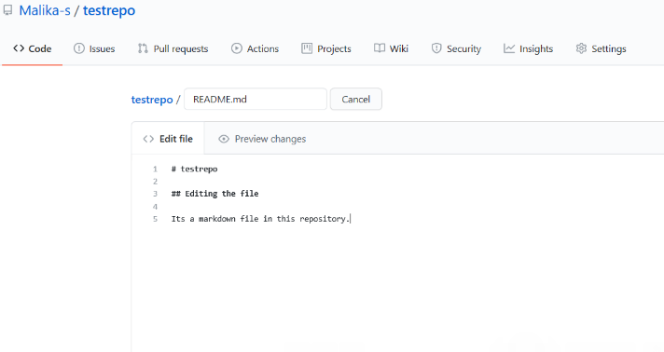
- Scroll to the bottom of the file and click Commit changes.
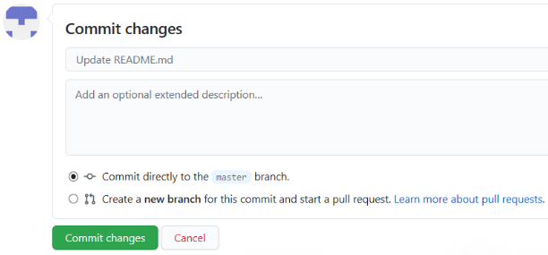
- Confirm that the text you added to the file has been saved.
Create a new file
- Click on the repository name to go back to the main branch, similar to this repository called testrepo.
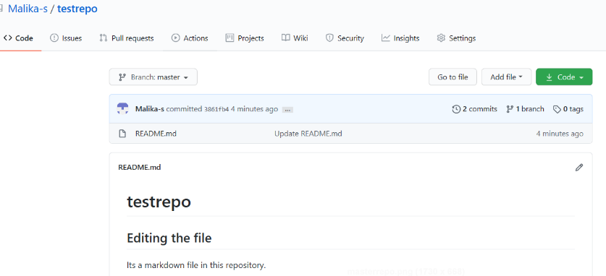
- Click Add file and select Create new file to create a new file in the repository.
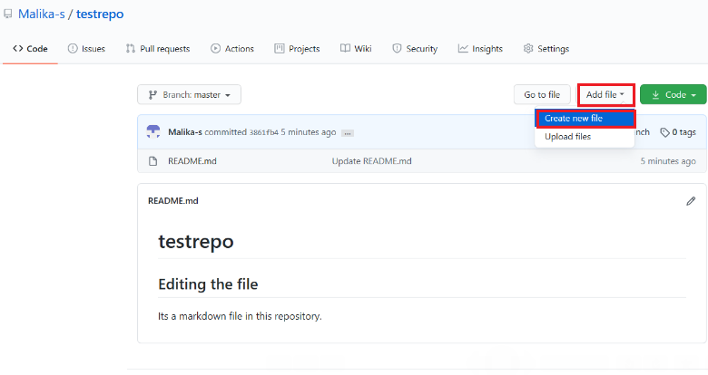
- Enter a file name and extension; for example, firstpython.py. Add the lines of code displayed in the following image to your file:
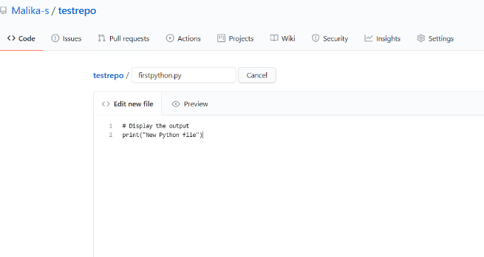
- Scroll to the bottom of the page. You can optionally add a description of your update (for example, "Adding a new file"). Click Commit to create your new file.
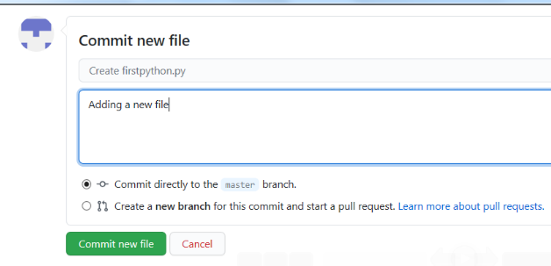
Your file is now added to your repository and the repository listing shows when the file was added or last revised.

4. Upload and commit a file
To upload a local file and commit it to your repository, complete the following steps:
- On your repository page, click Add file and then select Upload files to upload a file.
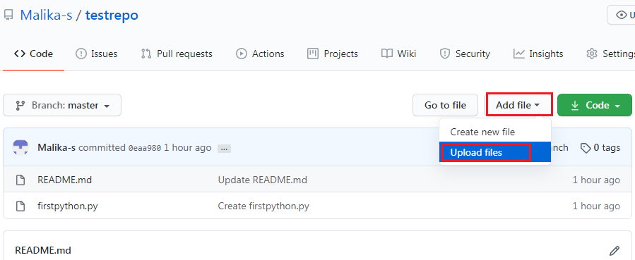
- Click choose your files and choose a file from your computer. You can upload any file (for example, a .txt, .ipynb, or .png file) to the repository.
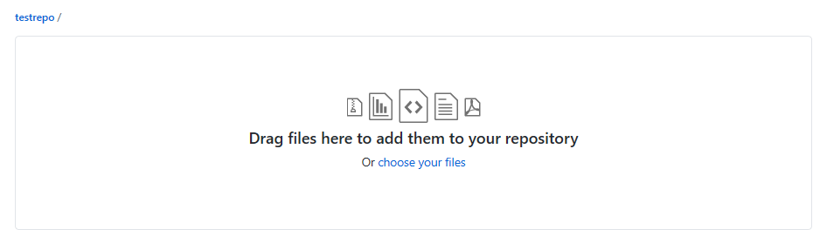
- When the file finishes uploading, click Commit changes.
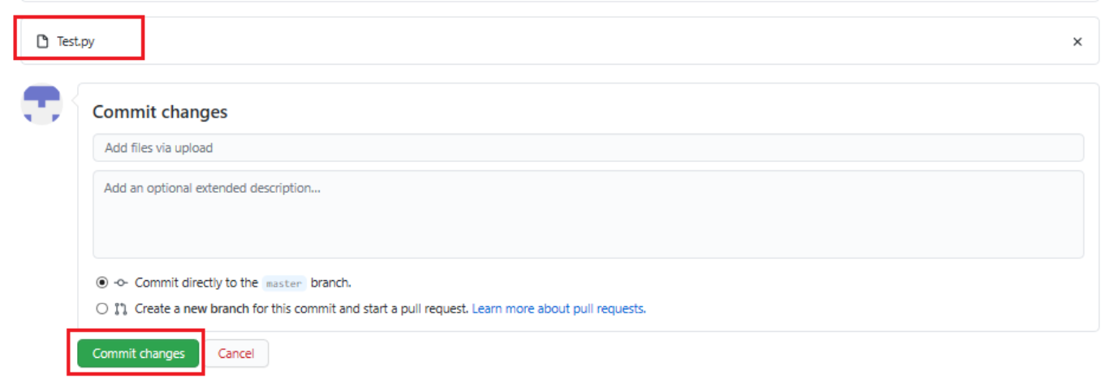
Your file is uploaded in the repository.
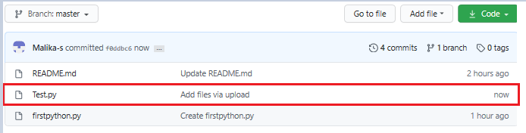

Summary
Congratulations! In this lab, you have learned how to create a new repository, add a new file, edit a file, upload a file, and commit your changes. We encourage you to continue to update your repository to become familiar with the processes that you have learned.

GitHub Branches

Welcome to GitHub Branches! After watching this video, you will be able to: Explain the purpose of branches and describe how to merge changes into branches. All files in GitHub are stored on a branch. The master branch is definitive. It stores the deployable version of your code. The master branch is created by default, however, you can use any branch as the main, finished, deployable version of the code. When you plan to change things, you create a new branch and give it a descriptive name. The new branch starts as an exact copy of the original branch. As you make changes, the branch that you created holds the changed code. To create a new branch, click drop-down branch: master Add new branch name into new branch text and select Create branch. GitHub branches can be very complex for large software projects. For a simple project, such as the ones we are exploring, consider the following: Start with a common base, the initial source for this project. At one point, the code is branched while new features are developed. In this example, both branches are undergoing changes. When the two streams of work are ready to merge, each branch’s code is identified as a tip. and the two tips are merged into a third, combined branch. Developers work on source files in a branch. Since some projects take a while, the source doesn’t make sense right away. To change the contents of a file: Select the file. Click the pencil icon. Make the changes. Commit the changes. When the developer has completed their assigned work, to save their changes, they commit the code. Commit indicates that the developer is convinced that the code represents a stable platform for the feature or set of features being developed. When a developer commits changed source to their path, they are required to write a comment that describes the changes. The comment should be meaningful and descriptive. The developer can choose to commit to the current branch or create a new branch. Some best practices : Don’t end the commit message with a period. Keep commit messages under 50 characters – use the extended window for the details. Always write in an “active” voice. Pull is used to initiate the merging of branches in a way to capture changes. A pull request makes the proposed (committed) changes available for others to review and use. A pull can follow any commits, even if code is unfinished. A pull requires a user to approve the changes. This can be the author of the change or it can be assigned within the team. Note that GitHub automatically makes a pull request on your behalf if you make a change on a branch that you do not own. Since the log files are immutable, it is always possible to find the person who approved the merge of the change. To open a new pull request: Click Pull request and select New pull request. Select the new branch from the compare box. Scroll down to view the changes. Confirm that the changes are what you want to assess. Add a title and description to the request. Click Create pull request. The intent of Git repositories is for the master branch to be the only deployed code. Developers can change source files in a branch but the changes are not released until. They are committed. A pull command is issued. The code is reviewed and approved. The approved code is merged back into the master code. To merge a committed code change into your master code: Click Merge pull request. Click Confirm merge. When all changes for a branch are complete, that branch is considered obsolete and it should be deleted. In this video, you learned: All files in GitHub exist on a branch. The Master Branch contains the finished, deployable version of the code. Create new branches when you need to change the code. The new branch starts as an exact copy of the original branch. As you make changes, the branch that you created holds the changed code. More than one branch can be undergoing changes at the same time. Saved changes are called commits. Pull requests enables other users to review and use the proposed changes (committed). When you are ready to merge the changed code into the master branch, you merge the committed code changes into your master code.

Generate an SSH key
Estimated time: 20 minutes

What is an SSH key?
An SSH key is an access credential in the SSH protocol. Its function is similar to that of user names and passwords, but the keys are primarily used for automated processes.

Generating an SSH key
To generate an SSH key, complete the following steps:
- Launch a terminal. If you are using Windows, launch Git Bash.
- Type the following command in your terminal, replacing <your email address> with the email address that is linked to your Github account. When you have typed the command, press Enter.
ssh-keygen -t rsa -b 4096 -C "<your email address>"
A new SSH key is generated.
- You will be prompted to enter a directory to save the key. You can simply press Enter to accept the default location, which is an .ssh folder in the home directory. This means you will be able to locate the key in ~/.ssh/id_rsa.
- You will be prompted to choose a passphrase. You also have the option not to create a passphrase. To skip the passphrase, press Enter twice to confirm that the passphrase is empty.
- Optional: To navigate to the .ssh directory, and check the contents of the directory, run the following commands in the terminal:
cd ~/.ssh
and then,
ls
When you list the contents of the .ssh directory, you should see id_rsa and id_rsa.pub in the list of contents, where id_rsa is the private version of your key and id_rsa.pub is the public version of your key.
- You now need to add the SSH key to the ssh-agent, which helps with the authentication process. To start the ssh-agent, run the following command in the terminal:
eval "$(ssh-agent -s)"
- To add the key to the agent, run the following command in the terminal:
ssh-add ~/.ssh/id_rsa

Summary
Congratulations! You have now learned how to generate the SSH key.

Lab: Adding an SSH key to GitHub
Estimated time: 15 minutes

Prerequisites
This hands-on lab requires you to have already generated an SSH key. See the Generating an SSH key lab for instructions.

Steps
To add an SSH key to GitHub, you need to copy the SSH key that you generated in the previous lab. Open a terminal and then complete the following steps:
- In the terminal, run the following command:
cat ~/.ssh/id_rsa.pub | clip
Note: If clip doesn't work, run cat ~/.ssh/id_rsa.pub in the command line and the copy the output.
- Sign in to GitHub. At the top right, click the drop-down menu on your profile image and select Settings.
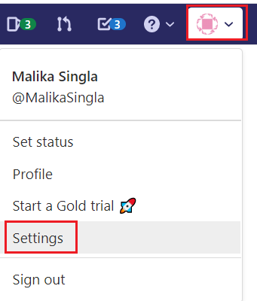
- From the "Personal settings" menu, select SSH and GPG keys, as shown in the following image:
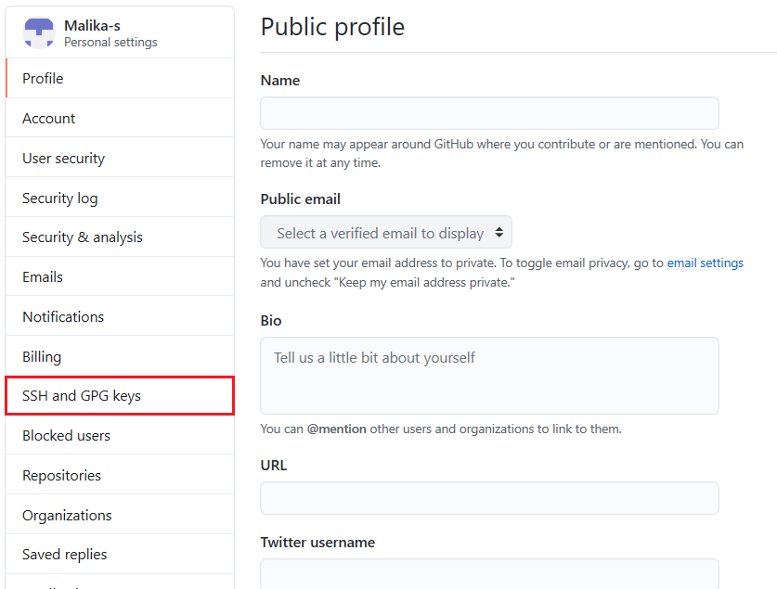
- Click New SSH key.
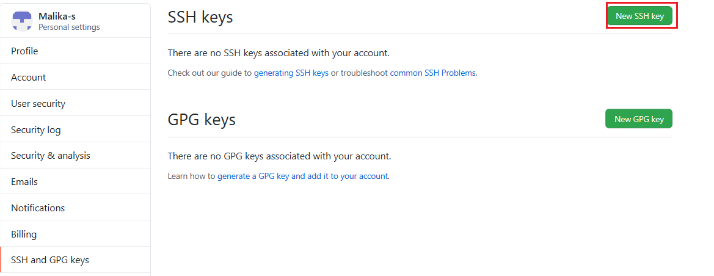
- Enter a title for the new SSH key. In the Key field, paste the key that you copied in step 1, above. The pasted key should include Your email address at the end, as shown in the following image:
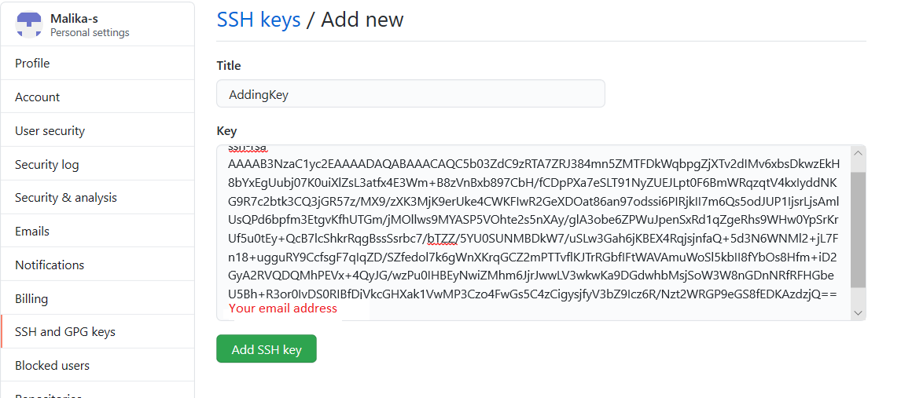
- Click Add SSH Key. The SSH key is added to your account.

Summary
Congratulations! You have now learned how to add an SSH key to GitHub.

Hands-on Lab: Cloning, committing and pushing your GitHub repo from the command line.
Effort : 30 mins

Objectives
After completing this lab you will be able to:
- Clone your GitHub repository locally.
- Make changes to the cloned files.
- Add a new file.
- Check the status.
- Commit changes.
- Push the changes back to GitHub.

Pre-requisites
GitHub account, with a project in it, as illustrated in the this lab.
GitBash or git installed on your local desktop, as in this lab.
Create ssh keys, as in this lab
Add SSH Key to GitHub, as in this lab

Exercise 1: Clone a repo
To clone a repo, you need the ssh url of the repo.
- To get the ssh url, login into GitHub.
- Navigate to the repo you wish to clone.
- Click on the 'Code' button.
- Click on the 'clipboard icon' to copy the url. Paste this url where you can access it later.
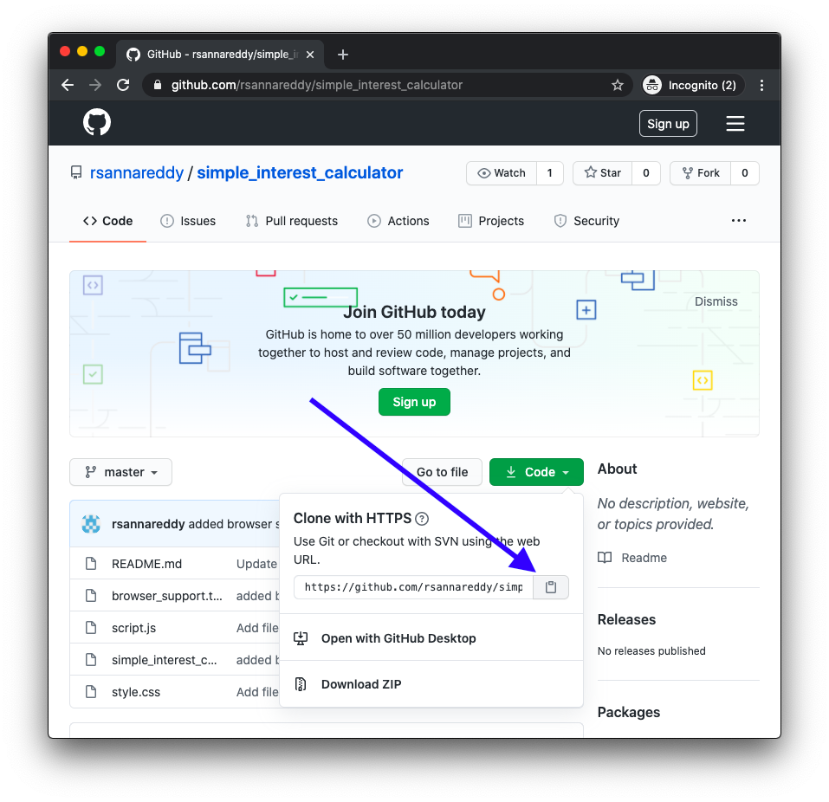
- On your desktop open a terminal.(gitbash if you are using windows os)
- Navigate to a directory where you wish to clone the repo.
- Run the command "git clone
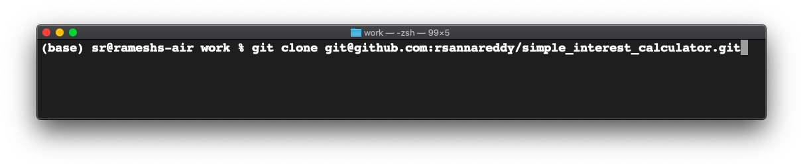
- This will clone the repo on GitHub into your current directory.
- You can see all the downloaded files under a directory named as your repo name.
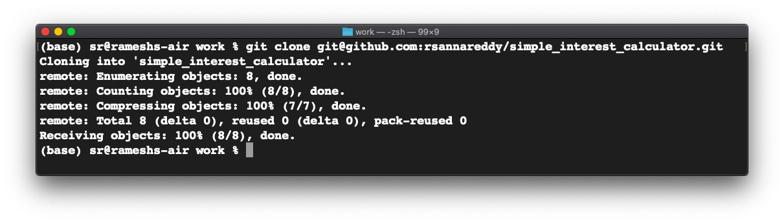
change to the simple_interest_calulator directory and list the files to verify all the files got downloaded

Exercise 2: Make changes to cloned files.
Using your favourite editor make the changes to the html file.
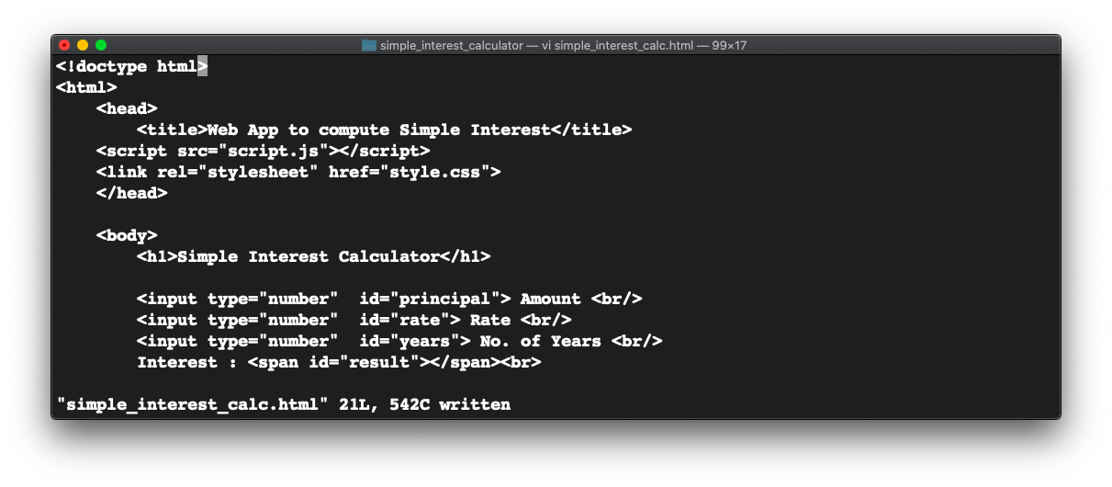
git status will show all the modified files.
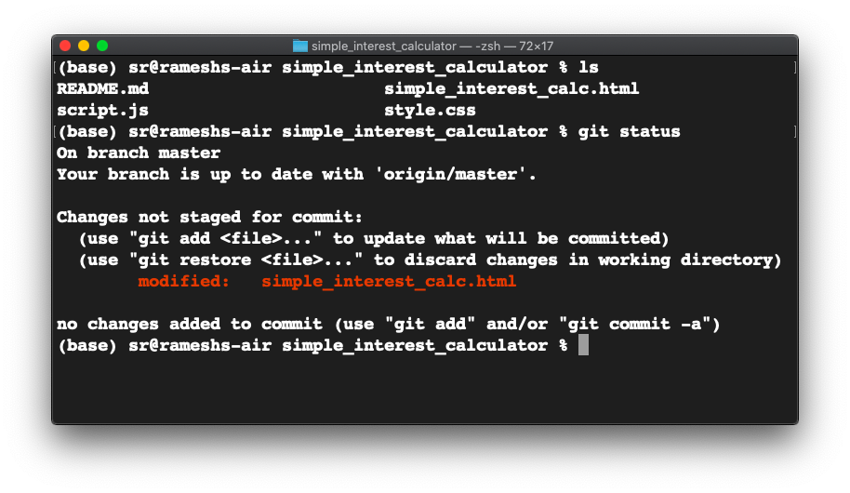

Exercise 3: Add a new file to the local repo
Let us add a new file to the local repo.
Using a text editor, create a new file "browser-support.txt".
Add "Chrome, Firefox, Edge" into the file.
Save the file.

Exercise 4: Check the status
Run "git status" to see info on the modified files.
Let us add the file for committing.
Run "git add browser-support.txt"

Exercise 5: Commit the changes
git commit will record all the changes into the local stating area.
To commit the changes you have made. Run git commit with a message like this.
git commit -m 'added a new file browser-support.txt'

Now all the changes you have made thus far, get committed locally.

Excercise 6: Generate Personal Access Token
- Verify your email address if it hasn’t been verified on Github.
- In the upper-right corner of any page, click your profile photo, then click Settings.
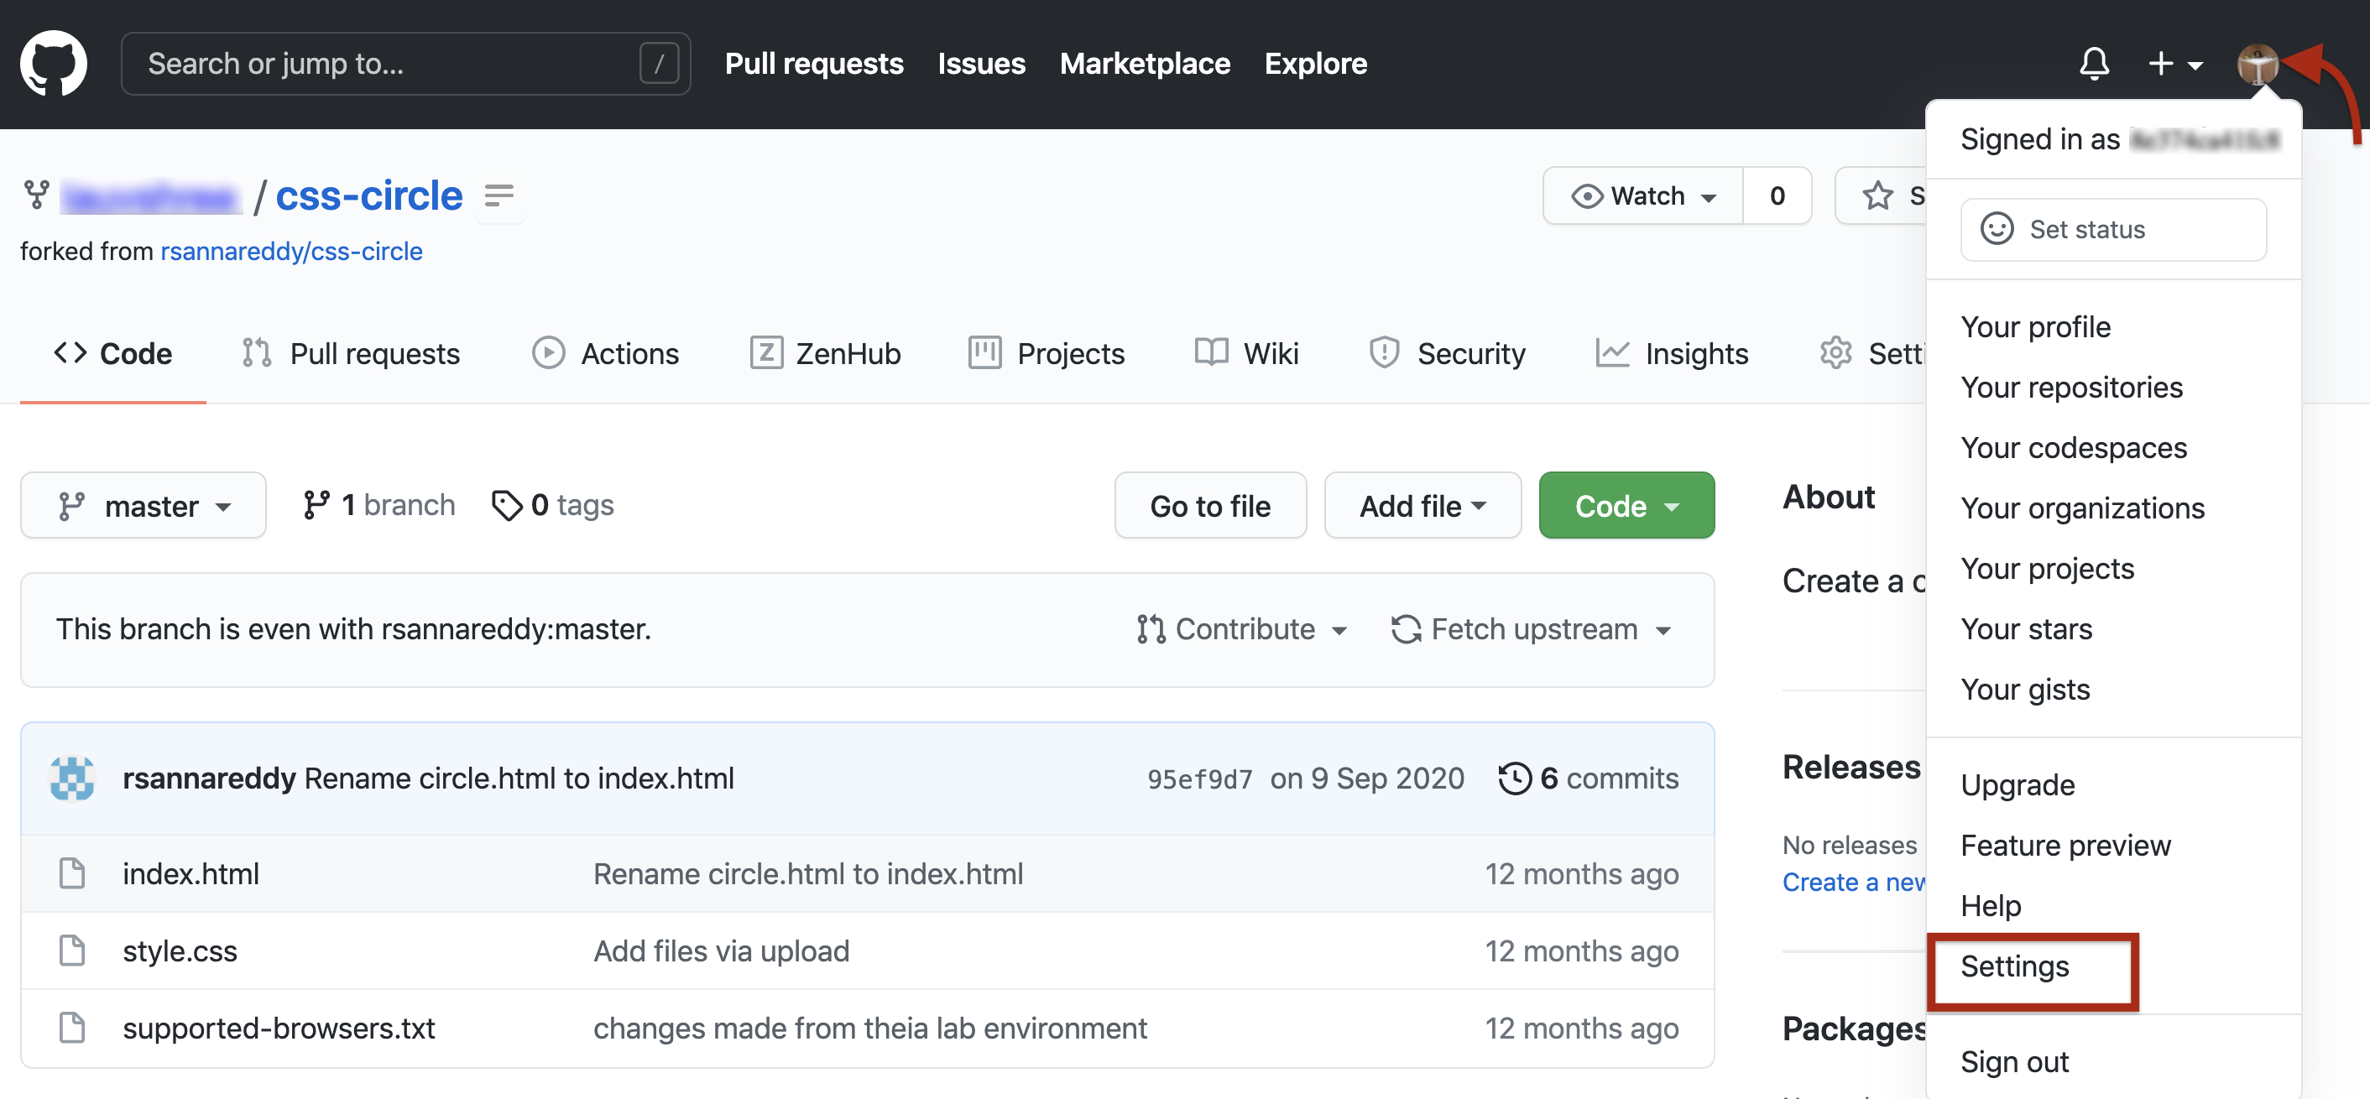
- In the left sidebar, click Developer settings.
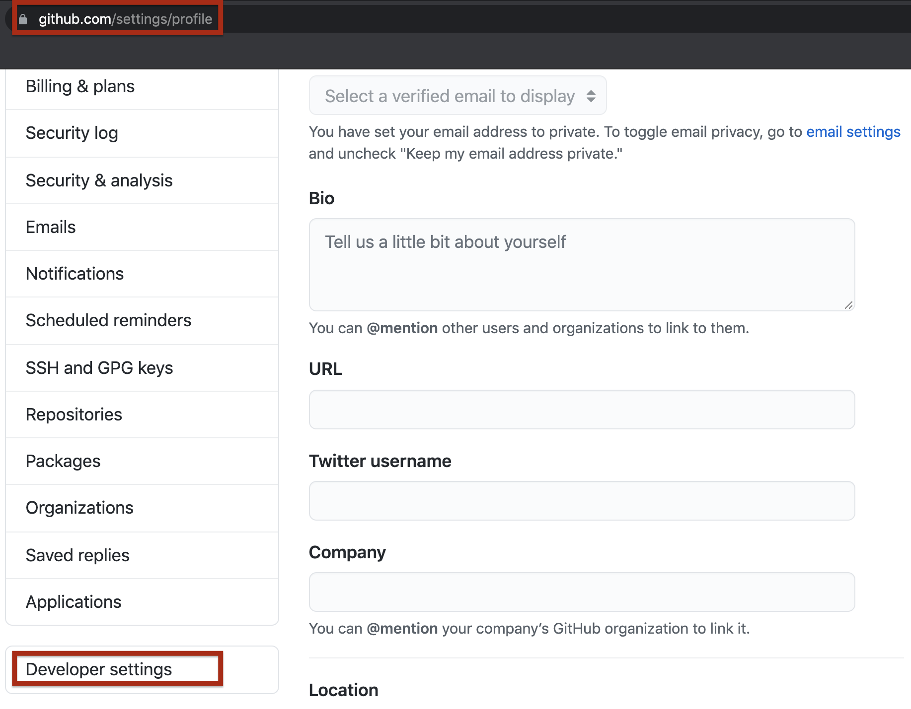
- In the left sidebar, click Personal access tokens and click on Generate Tokens
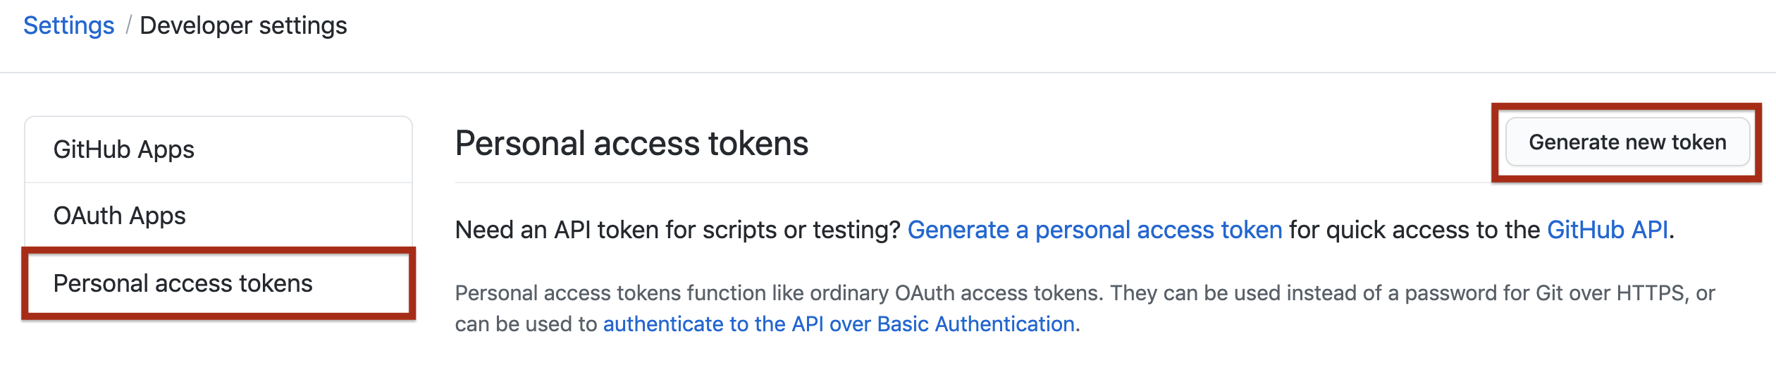
- Give your token a descriptive name. To give your token an expiration, select the Expiration drop-down menu, then click a default or use the calendar picker. Select the scopes, or permissions, you'd like to grant this token. To use your token to access repositories from the command line, select repo.
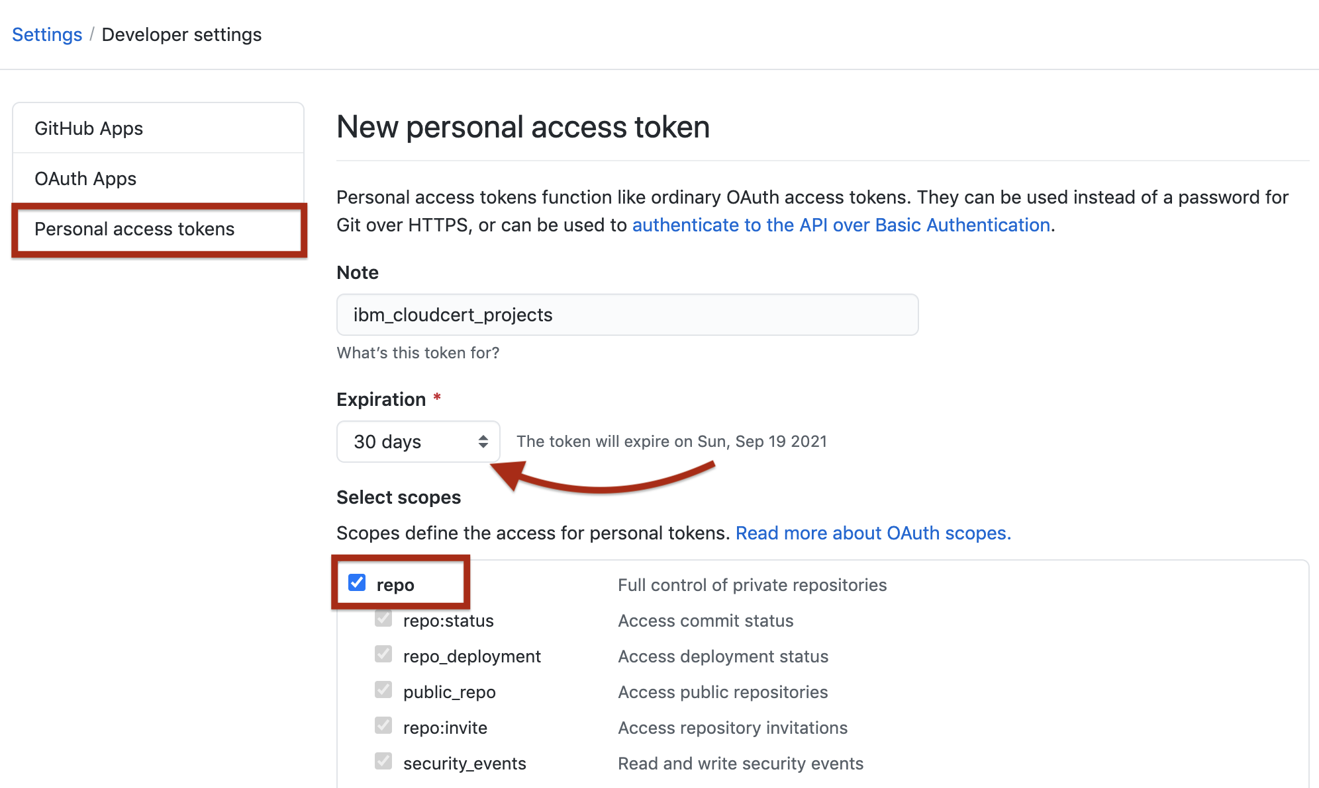
- Click Generate token and make a note of it.
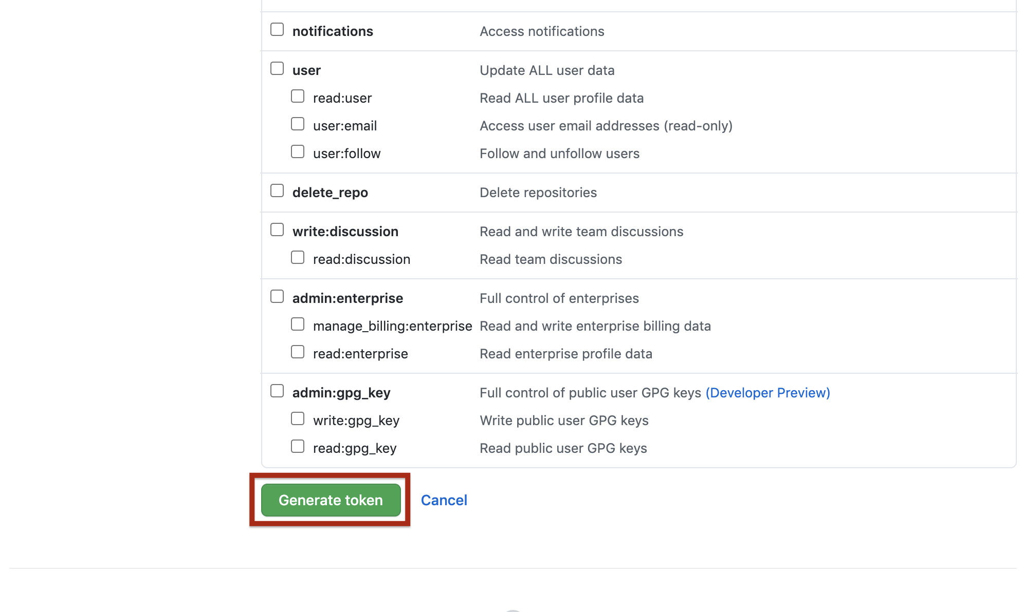
- Make sure you copy the token and keep it safe. It is not visible to you again.
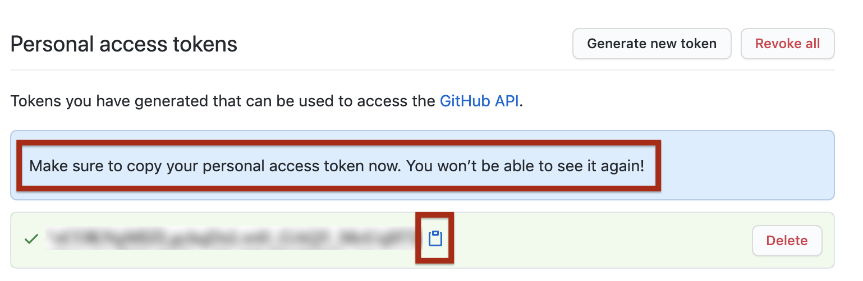
Treat your tokens like passwords and keep them a secret.
Once you have a token, you can enter the Personal Access Token as password when performing Git operations.

Excercise 7: Push the code to GitHub
The git push command will enable you to sync all the changes made locally to the GitHub web repository.
1. Run the following command with your actual HTTPS link:

`git push [HTTPS link]`

You will be prompted by git for your username and password.

2. Type your GitHub username and for the password, enter the personal access token you generated in the previous task. When you are authenticated, all committed changes are synced with your GitHub repository.
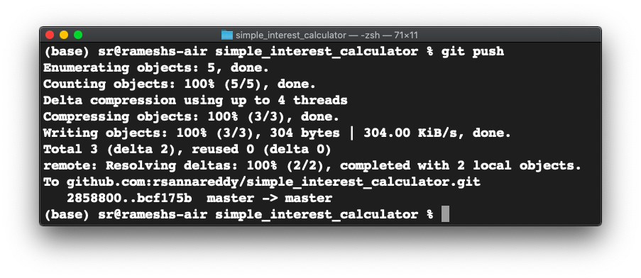
You can now visit the GitHub repository page and check to ensure that the revised and newly added files are in place.

Summary
In this lab, you have learned how to clone a GitHub repository, make changes to it, commit the changes locally, and push it back to GitHub.

